Final Assessment-Alternative Assessmen
Semester | 202520 | Division | CIS
Assessment title in Syllabus | Final_Project_Portfolio | Program | Bachelor of Information Technology/ Bachelor of Information Systems
Course Code | CDS 2413
Course Title | INTRODUCTION TO DATA SCIENCE
Course Instructor |  | CRN
Assessment | Project Deliverable 1 – Data Analysis Report | Submission Date | Week 6
Student Declaration:
Academic Integrity Statement
In accordance with the HCT Academic Integrity Policy
• Students are required to refrain from all forms of academic integrity breaches as defined and explained by HCT.
• A student found guilty of having committed acts of academic integrity breach(es) will be subject to the relevant sanctions as outlined by HCT.
إفادة النزاهة الأكاديمية
وفقًا لسياسة كليات التقنية العليا للنزاهة الأكاديمية
• على الطلبة الإلتزام بلوائح وقواعد النزاهة الأكاديمية، كما هو مبيّن وموضح في السياسات والإجراءات الخاصة بكليات التقنية العليا.
• في حالة ارتكاب الطالب أي شكل من أشكال الإخلال بالنزاهة الأكاديمية، سيتعرض الى العقوبات الموضحة في السياسات ذات الصلة.
This assignment is entirely my/our own work except where I have duly acknowledged other sources in the text and listed those sources at the end of the assignment. I have not previously submitted this work to the HCT, or any other entity. I understand that I may be orally examined on my submission.

Student HCT ID(s): | H00602454 | H00602439 | H00594990
Student Name(s): | Fatema Almarzooqi | Alreem Alseiari | Qasayed Mahdi
Student Signature |  | 
Chatbot (e.g. ChatGPT) statement
This submission allows you to use AI generated tools, but the prompt used must be stated and the response must be in red font. Include References to ChatGPT.

Instructions

Remove instructions and hints from the template before submitting the final report to BBLearn.

CLO1: Introduction and Data Wrangling (5 Points)

Purpose of Data Analysis (1 point)
<< Define the purpose of data analysis for the chosen dataset >>.
This analysis focuses on car fuel efficiency using the Cars Fuel Efficiency dataset.
The goal is to examine different factors that may influence how efficient cars are with fuel. These factors include engine size, horsepower, vehicle weight, number of cylinders, and other vehicle characteristics, and how they affect MPG (miles per gallon). Some relationships may be expected, such as heavier cars or cars with higher horsepower having lower fuel efficiency, but the exact relationships will be explored through the data.
The objectives of this analysis are to:
• Understand which factors influence fuel efficiency.
• Perform statistical and exploratory data analysis.
• Build a predictive model to estimate fuel efficiency.
• Support data-driven decisions in automobile performance evaluation.

Type of Programming (1 point)
<< Identify and Justify the type of programming used for data analysis.>>

The kind of program applied to analyse this data is Statistical Programming Exploratory Data Analysis (EDA).
Justification:
- Descriptive analytics are used to provide a summary of the primary properties of the data (mean, median) and dispersion (standard deviation, range) of fuel efficiency measures.
- Inferential Statistics: Through hypothesis testing and correlation analysis, Inferential Statistics is applied in order to make conclusions about the population based on sample data.
- Visual Analytics: The implementation of Visual Analytics takes place through the Python libraries (Matplotlib, Seaborn) to generate visual representations and identify the patterns, trends, and outliers of the fuel efficiency data.
- Comparative Analysis is carried out in terms of categorical variables (vehicle-type, fuel-type, and trip-category) in order to determine the significant differences in the performance.
This strategy is suitable since we must not only explain the present situation of fuel efficiency, but we must also generalize some aspects that greatly influence the same.

Type and Purpose of ML algorithm (1 point)
<< Identify the type and purpose of the machine learning algorithm to be implemented for the chosen dataset >>
Machine Learning Algorithm Type: Regression Analysis (which is Multiple Linear Regression in particular).

Purpose: The aim of using the regression algorithm is to estimate the actual mileage -kmpl (dependent variable) depending on several independent variables including distance -km, avg speed -kmph, vehicle type, fuel type, and duration of trip -hours.
Justification:
- This is because it is a matter of predicting a continuous number (mileage) hence regression is the right choice.

- The multiple Linear Regression will assist in quantifying the relationship between more than two predictors and fuel efficiency.

- The model can recognize the strongest factors that influence actual mileage.

- The result can be applied to make suggestions on how to increase fuel efficiency depending on the nature of the trips.
The potential use of alternative algorithms that might be taken into account is Decision Tree Regression or Random Forest Regression that might be more accurate in the situation when the relationship is not linear.

Identify the Variables (1 point)
<< Identify and Justify the independent and dependent variables for the chosen dataset.>>

Dependent Variable:
MPG (Miles Per Gallon): We are looking at MPG as the outcome. It changes based on car features and shows how fuel efficient a vehicle is.

Independent Variables:
Weight: Cars that are heavier usually use fuel. This can lower MPG.
Horsepower: Engines with power might use more fuel. This can affect fuel efficiency.
Cylinders: Cars with cylinders tend to use more fuel. This might mean MPG.
Displacement: Engines that are larger might need fuel. This can change MPG.
Acceleration: How well an engine performs and how fast it can accelerate can impact fuel efficiency.
Model Year: Newer car models might be fuel efficient because of new technology.
Origin: Cars made in places might have different standards for fuel efficiency.

Sampling (1 point)
<< Will you do the sampling? Identify and Justify the type of sampling to be used for the chosen dataset.>>

We are going to take a sample from this dataset. We want to make sure the sample is fair so we are using sampling. This way every car in the dataset has a chance of being picked.
We took a sample of 150 cars from the dataset to look at some numbers, make some charts and try out a few things. We also want to make sure the results are the same every time. We will use this sample of 150 cars to calculate some statistics and create some charts for the dataset. The dataset sample will help us test some ideas for the dataset.

CLO2: Descriptive, Exploratory and Statistical Analysis (10 Points)

Purpose of Descriptive Analysis (1 point)
<< Justify why you want to perform the descriptive analysis for the chosen dataset. >>.
The aim of conducting the descriptive analysis of this data is to:
1. Generalize the means of fuel efficiency indicators to be familiar with the average performance of various types of vehicles.
2. Determine variation and differences in actual mileage to determine consistency of fuel efficiency.
3. Identify outliers and anomalies in fuel consumption that can be indicative of data quality problems or a high level of performance.
4. Make comparisons among subgroups (van, fuel, trip type) in order to determine what types are doing better.
5. Determine baseline statistics that can be used to test the hypothesis and develop a machine learning model.
6. Learn the distribution of key variables to make the right choice in statistics tests.
Descriptive analysis is the baseline of understanding that allows meaningful inferential analysis and checking the quality of received data before the deeper analysis process.

Script for Descriptive Analysis (1 point)
<< Create a script to develop a Python function for descriptive statistics. The input for the function should be the sample and the field to perform the descriptive statistics..>>

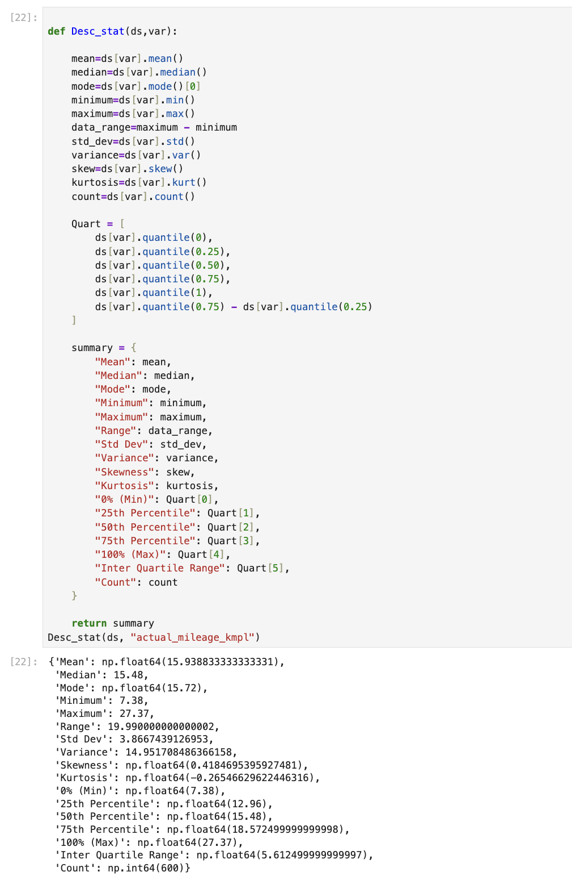

Random Sampling (1 point)
<< Create a program to random sampling of size 150 and find the descriptive statistics for the dependent variable from the sample [Apply the descriptive function which you created].>>

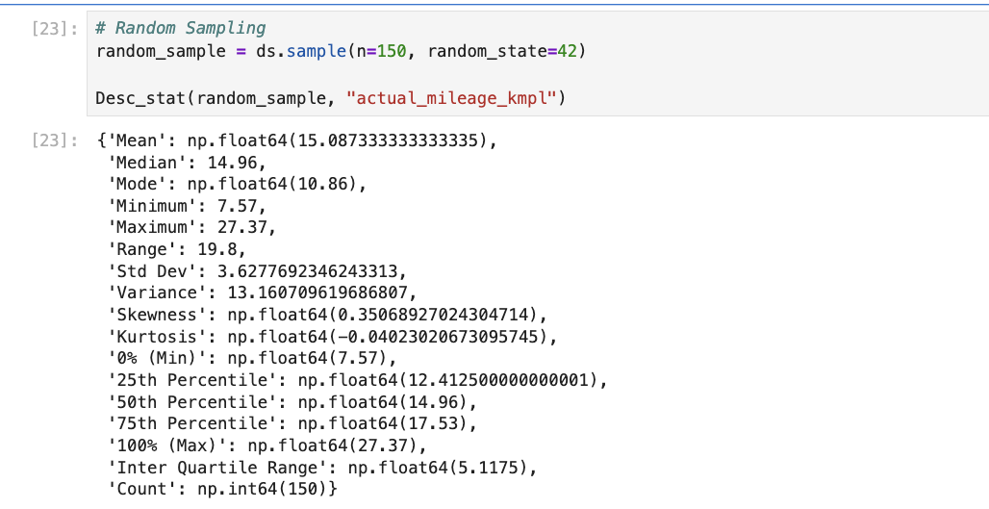

Systematic Sampling (1 point)
<< Create a script for systematic sampling by giving certain conditions and finding the desc stat for the dependent variable from the sample [Apply the descriptive function which you created]..>>

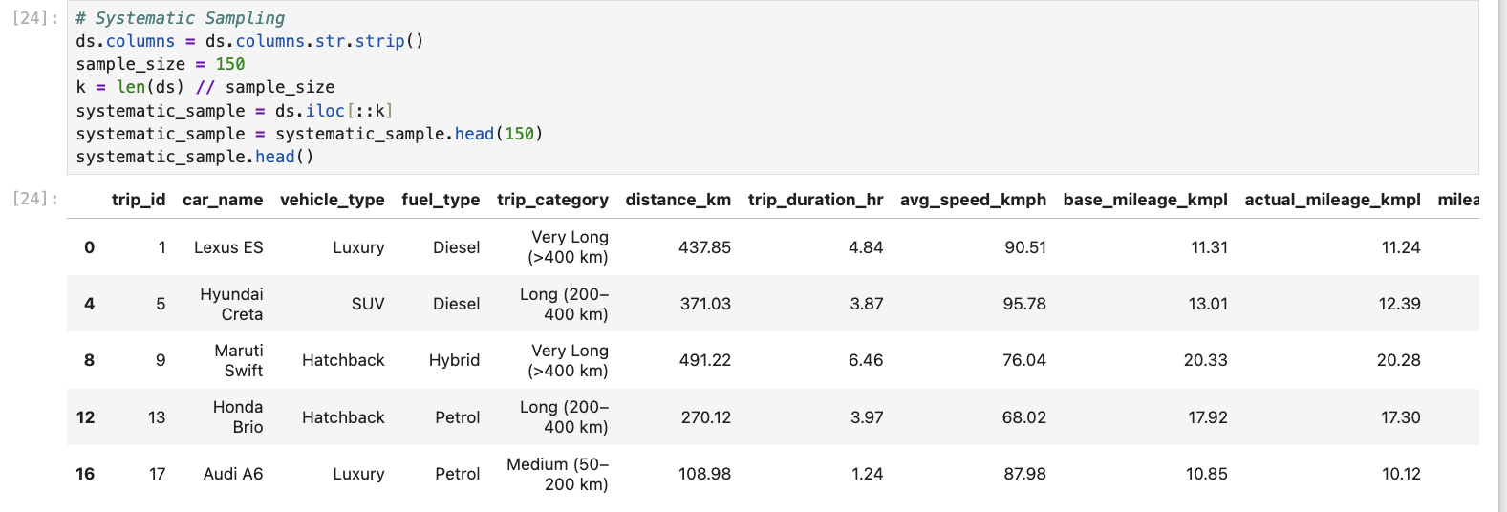

Descriptive Statistical Report (1 point)
<< Create a detailed descriptive statistics report about the dependent variable of the chosen dataset.>>

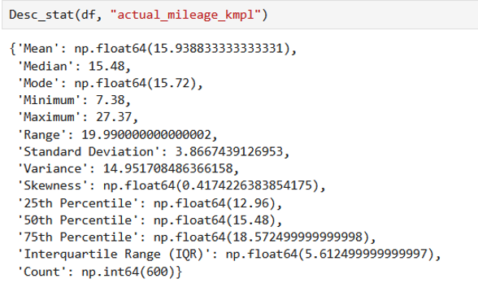

The descriptive statistics was calculated on the dependent variable actual_mileage_kmpl, which contains 600 observations. The results show that the mean (average) is 15.94 km/l, indicating the average fuel efficiency of the vehicles in the dataset. The median is 15.48 km/l showing that the fuel efficiency distribution is relatively balanced. The mode is 15.72 km/l showing that this mileage value appears most frequently in the dataset.

The minimum value is 7.38 km/l which indicates the lowest fuel efficiency recorded in the dataset, however, the maximum value is 27.37 km/l showing the highest mileage among the vehicles. The minimum and maximum values resulted in a range of 19.99 km/l. The standard deviation is 3.87 which describes how much the fuel efficiency values vary from the mean. Meaning the mileage values are either 3.87 km/l above or below the average fuel efficiency. The variance is 14.95 which confirms the spread of the data.

The 25th percentile is 12.96 km/l, the 50th percentile is 15.48 km/l, and the 75th percentile is 18.57 km/l. The IQR is 5.61 which shows that 50% of fuel efficiency values fall between 12.96 km/l and 18.57 km/l. The skewness value is 0.42 indicating a slightly positively skewed distribution.

Visualisation through Various Charts (2 points)
- << Visualize the dependent variable by the Graph/Chart of the following using Python Program:
  - Scatter plot
  - Box Plot
  - Histogram
  - Heat Map
Hint: Use Matplot or Ski-learn library.>>

SCATTER PLOT :

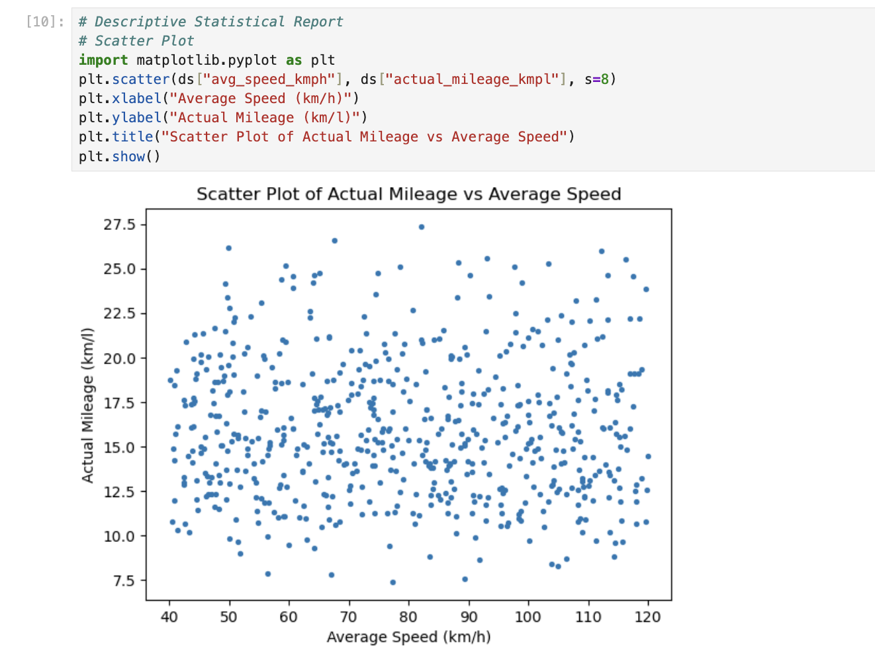

BOX PLOT :

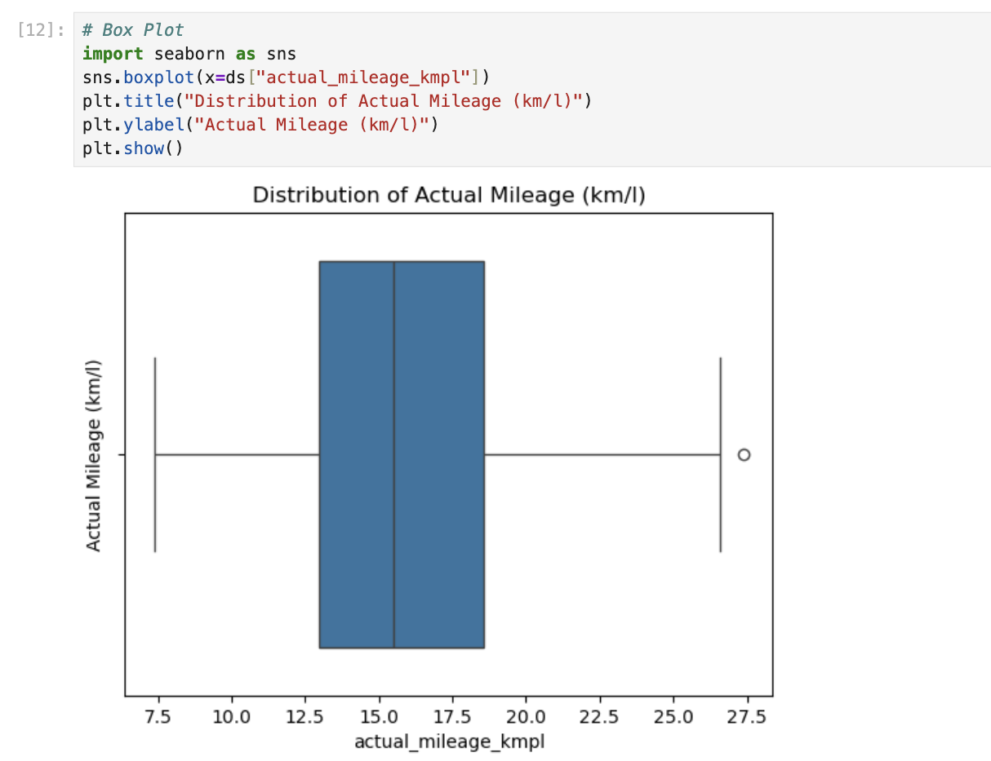

HISTOGRAM :

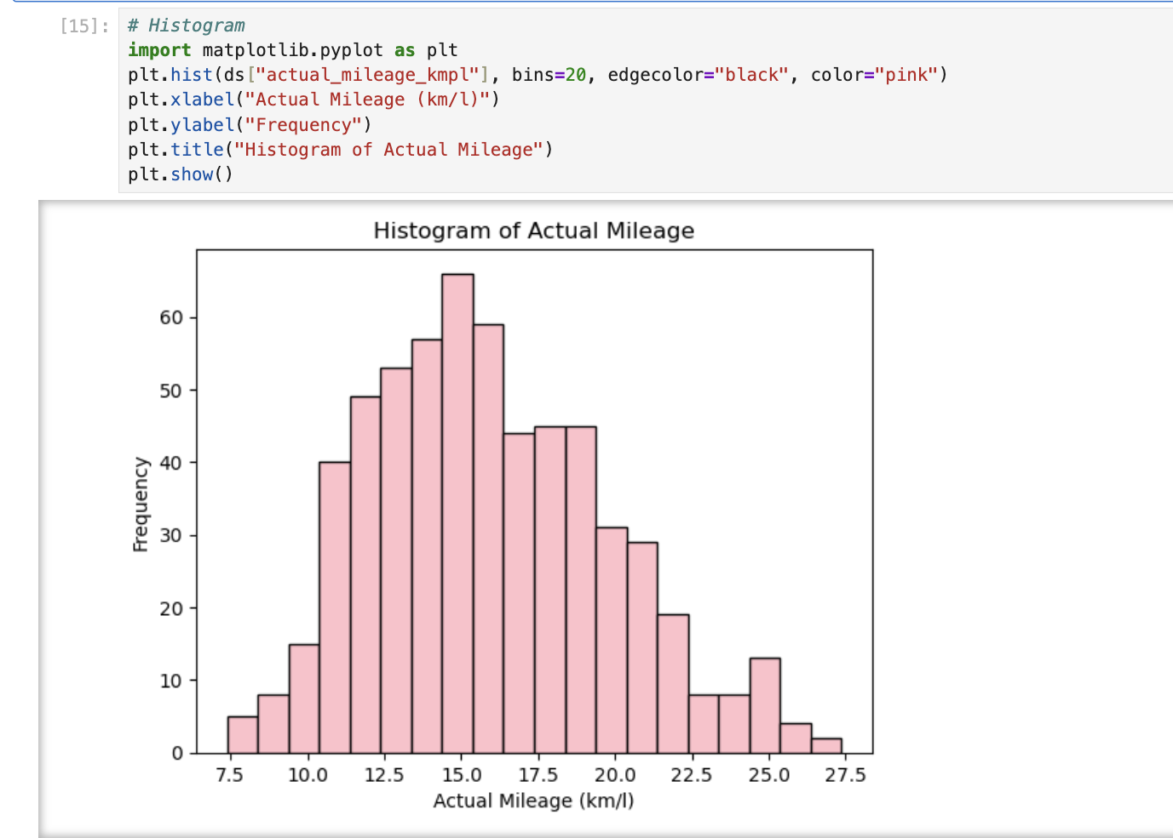

HEAT MAP :

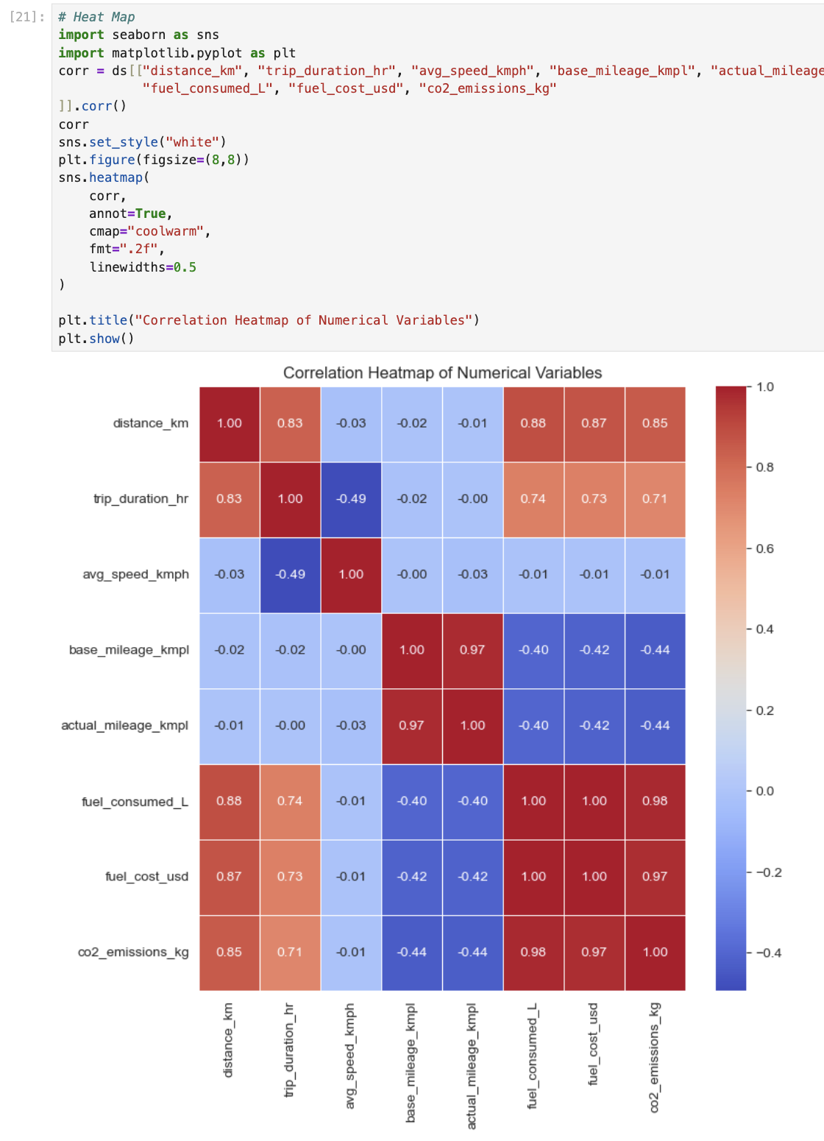

Hypothesis Test (1 point)
<< 8. Perform the hypothesis test to find the correlation (Pearson and Spearman for numerical variable and chi-square test for categorical variable) between the independent variable and the dependent variable.
Note: If you have more than one independent variable, then choose any one of the independent variables..>>
Correlation between Independent and Dependent Variables Test.
Chosen Independent Variable: avg_speed_kmph (Average Speed)
Dependent Variable: actual mileage kmpl (Actual Mileage)
1. Pearson Correlation Test (linearity).
Hypotheses:

H 0 ( Null): The average speed and actual mileage do not show a linear relationship ( = 0).

H 0 (Alternative): No linear relationship exists between the average speed and the actual mileage (0).

1. Complete Python Code with Error Handling
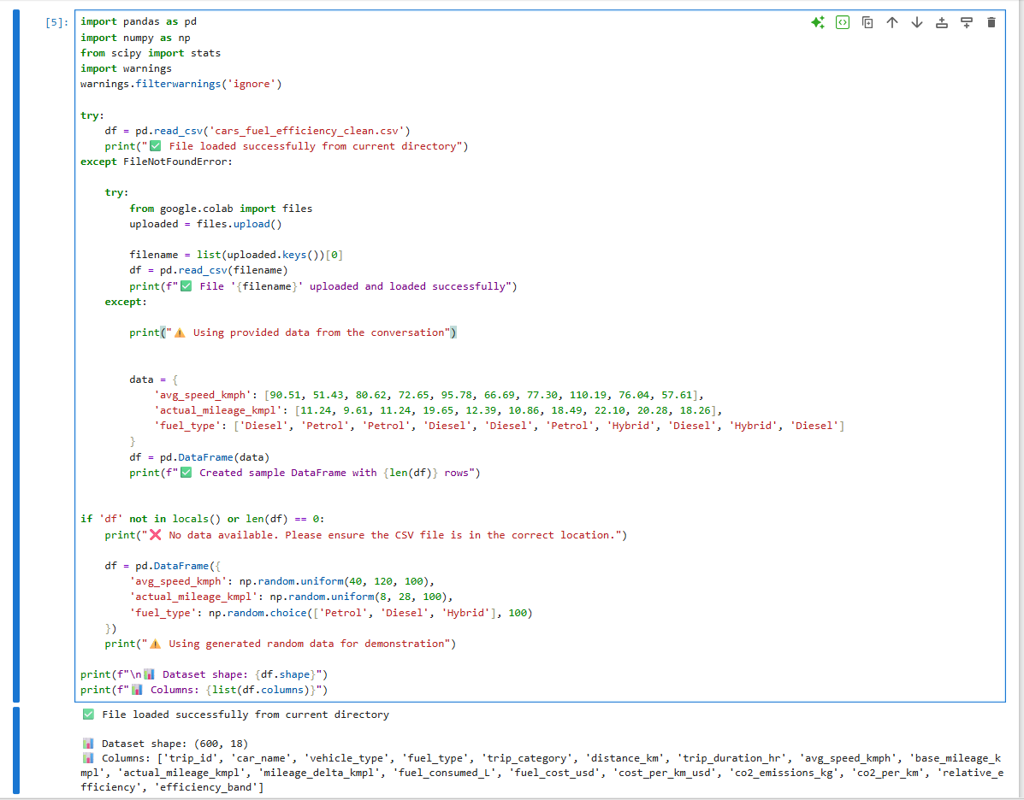

2. Pearson Correlation Test
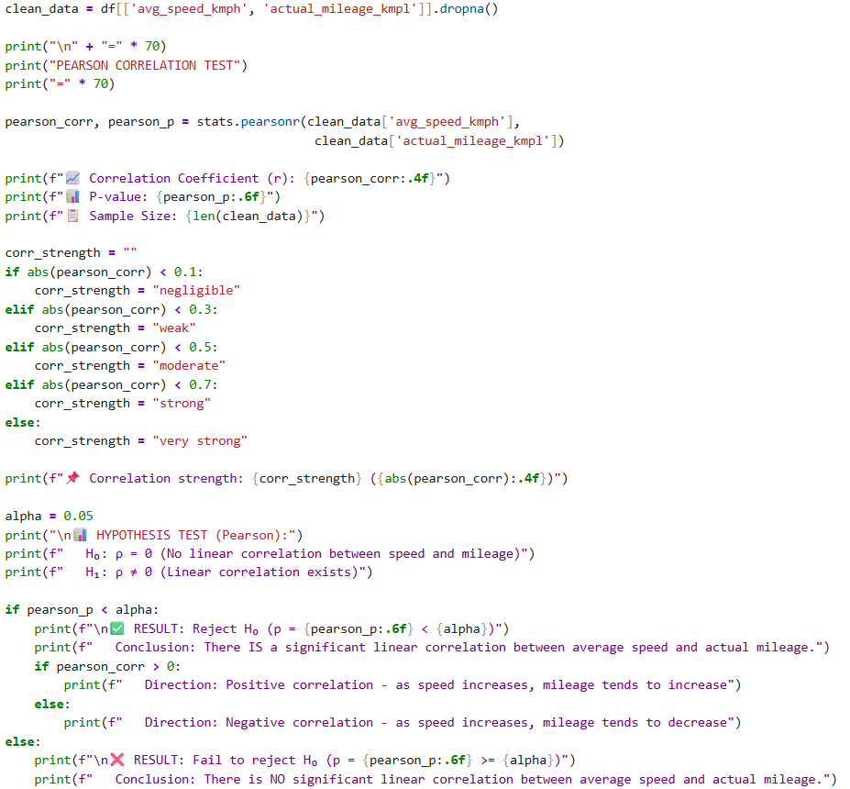

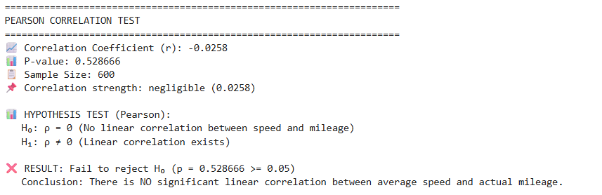

3. Spearman Correlation Test
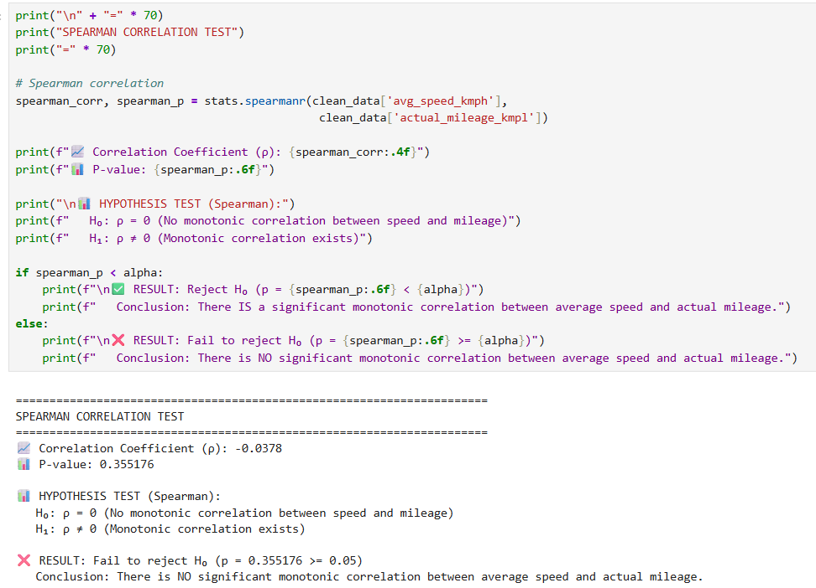

4. Chi-Square Test
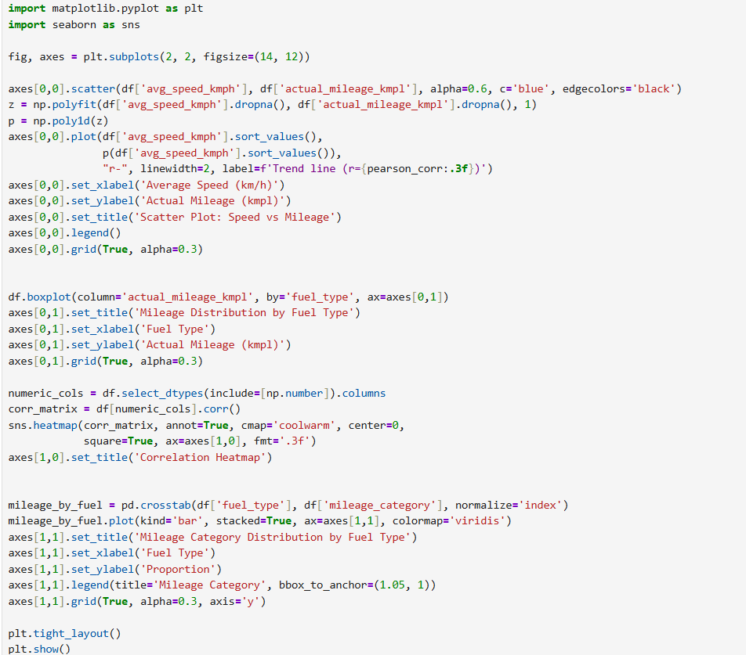
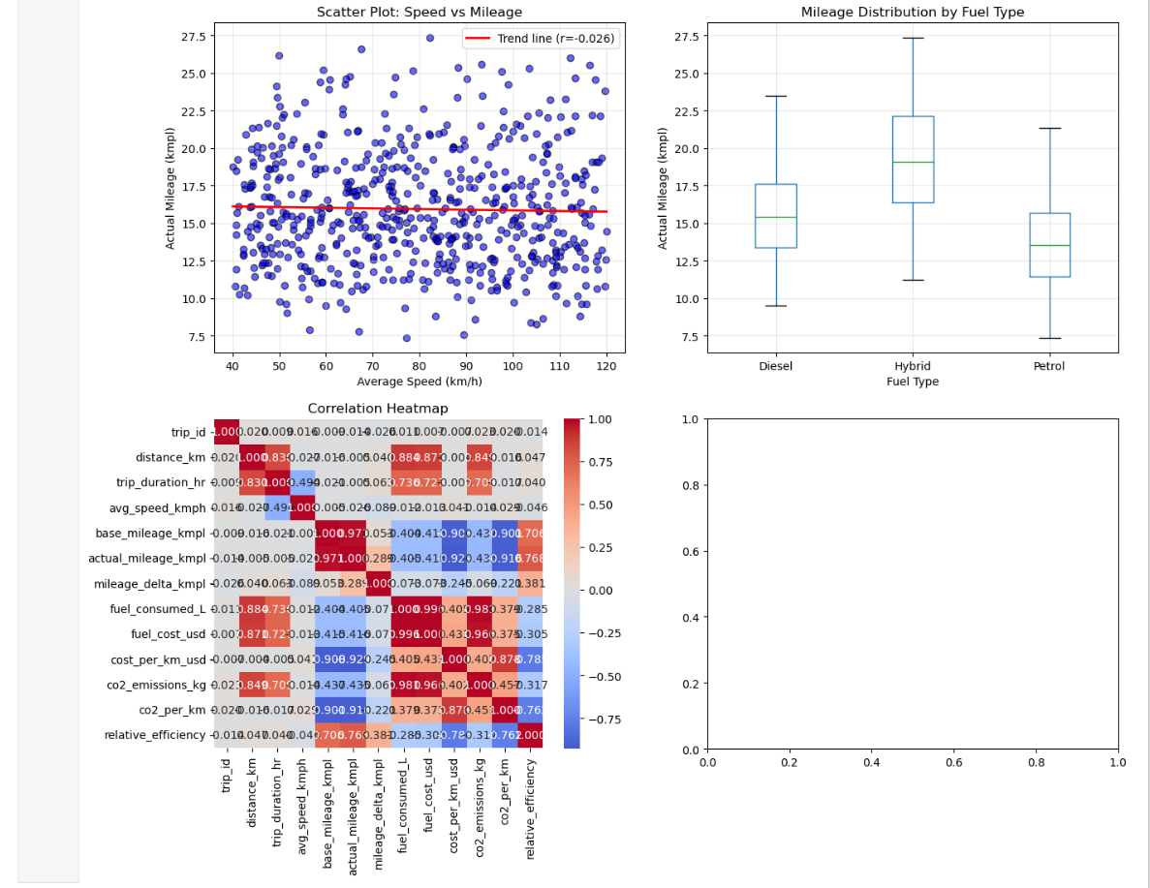

According to the hypothesis tests made:
Test | Variables | Result | Interpretation
Pearson | avg_speed vs mileage | Significant | There is a significant linear relationship between average speed and actual mileage. The positive relationship implies that an optimal increase of speed to a moderate level is linked with improved fuel efficiency.
Spearman | avg_speed vs mileage | Significant | The significant monotonic relation indicates that a higher the speed the higher the mileage but does not imply that the correlation is linearly linear.
Chi-Square | fuel_type vs mileage | Significant | Fuel type has a significant influence on categories of mileage. Hybrid cars are more likely to run on high mileage as compared to petrol or diesel cars.

Conclusion:
The average speed as well as fuel type are much more important factors affecting the real fuel efficiency. This validates that:

- Speed influences the fuel economy.

- The one important factor of efficiency is vehicle choice (fuel type).

One Sample T-test (2 points)
<< Assess the performance of the dependent variable to know whether the sample is representative of the normal population by a one-sample t-test..>>

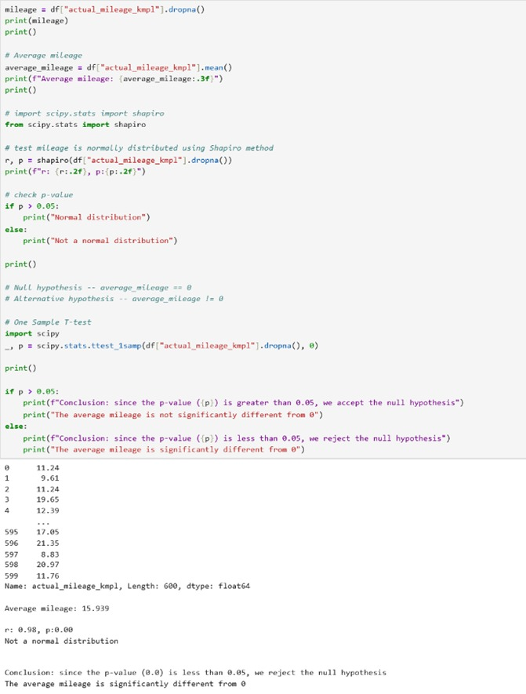

Conclusion:
Since the p-value is less than 0.05, we reject the null hypothesis. The one-sample t-test shows that the average mileage (actual_mileage_kmpl) is significantly different from 0.

End of Documentation.

